**ETCD backup/snapshot & restore**

1. **Sudo apt update**
2. **Sudo apt install etcd-client**
3. Now, lets take snapshot, for that search below terms in etcd.yaml
   1. **ETCDCTL_API=3 etcdctl --endpoints=https://127.0.0.1:2379 --cacert=<trusted-ca-file> --cert=<cert-file> --key=<key-file> snapshot save <backup-file-location>**
   2. Ex. ETCDCTL_API=3 etcdctl --endpoints=https://127.0.0.1:2379 --cacert=/etc/kubernetes/pki/etcd/ca.crt --cert=/etc/kubernetes/pki/etcd/server.crt --key=/etc/kubernetes/pki/etcd/server.key snapshot save /root/backup

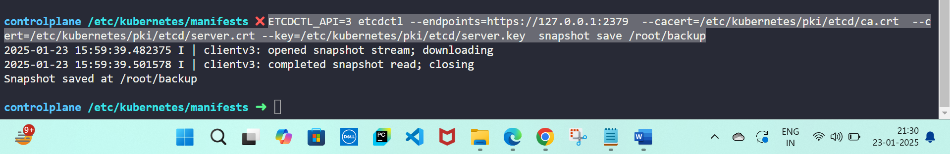

1. Now, let us restore it,
   1. **export ETCDCTL_API=3 etcdctl --data-dir <data-dir-location> snapshot restore snapshot.db**
   2. Ex. export ETCDCTL_API=3 etcdctl --data-dir /root/newbackup snapshot restore /root/snapshot.db
2. Once you restore it, you need to restart the kubelet.service,
   1. **Systemctl restart kubelet.service**

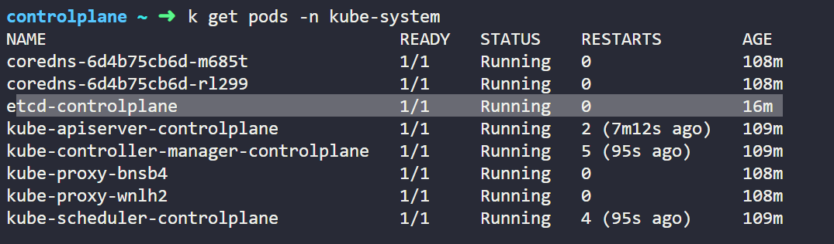

So, I created few pods after taking the snapshot and when I restored the snapshot, the cluster came back to its original state, which means no pods there, which means the etcd was restored correctly.

